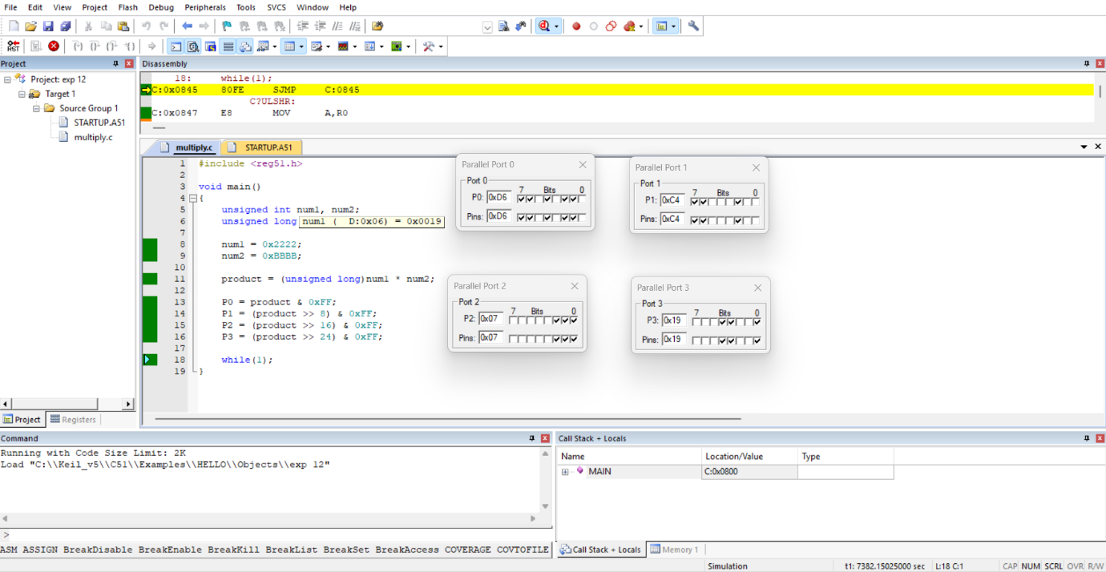
Experiment 12:

Source code:
#include <reg51.h>
void main()
{
unsigned int num1, num2;
unsigned long product;
num1 = 0x2222;
num2 = 0xBBBB;
product = (unsigned long)num1 * num2;
P0 = product & 0xFF;
P1 = (product >> 8) & 0xFF;
P2 = (product >> 16) & 0xFF;
P3 = (product >> 24) & 0xFF;
while(1);
}

